Maisha Jahan

Professor Monshi

CMSC 203

Assignment 1

Eclipse

Test Case #1

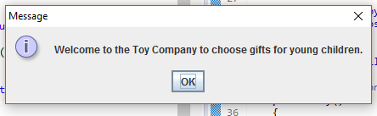

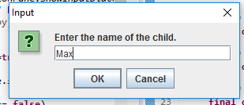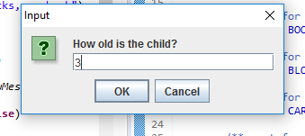

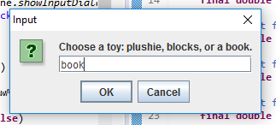

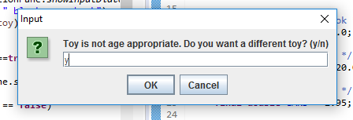

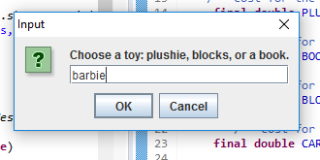

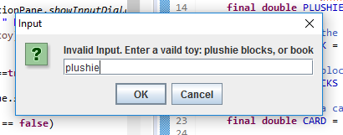

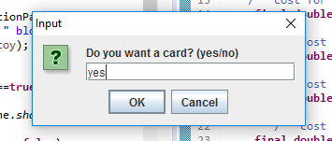

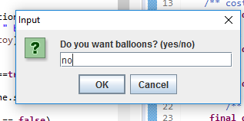

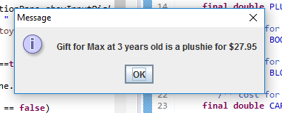

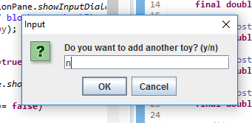

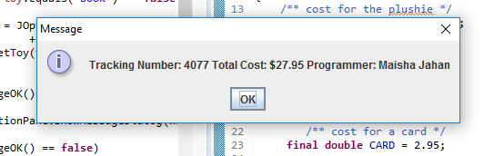

Case #2



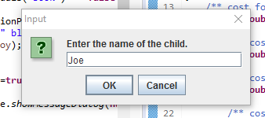

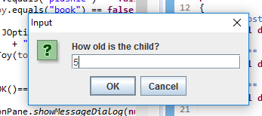

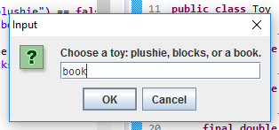

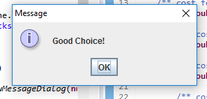

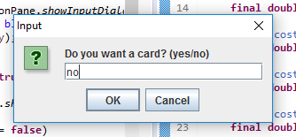



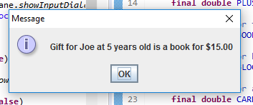



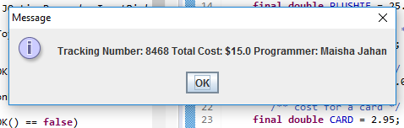

Test Table

Case #1

|  |  |  |  |  |  |  |
| --- | --- | --- | --- | --- | --- | --- |
| Name | Age | Toy | Message | Card | Balloon | Cost/ Total |
| Max | 3 | Book | Toy is not age appropriate. Do you want a different toy?  Yes  Enter Barbie  Invalid Input. Enter a valid toy  Blocks | yes | no | 22.95 |
| Kimi | 5 | Book | Good Choice! | no | no | 15.00 |

Total: 37.95

Case #2

|  |  |  |  |  |  |  |
| --- | --- | --- | --- | --- | --- | --- |
| Name | Age | Toy | Message | Card | Balloon | Cost/Total |
| Lando | 7 | Plushie | Toy is not age appropriate. Do you want a different toy?  No | Yes | Yes | 33.95 |

Total: 33.95

Case #3

|  |  |  |  |  |  |  |
| --- | --- | --- | --- | --- | --- | --- |
| Name | Age | Toy | Message | Card | Balloon | Cost/Total |
| Carlos | 1 | plushie | Good Choice! | yes | yes | 33.95 |
| Charles | 6 | plushie | Toy is not age appropriate. Do you want a different toy?  No | yes | Yes | 33.95 |

Total: 67.90

Case #4

|  |  |  |  |  |  |  |
| --- | --- | --- | --- | --- | --- | --- |
| Name | Age | Toy | Message | Card | Balloon | Cost/Total |
| Ocon | 3 | Car | Invalid Input. Enter a valid toy  Barbie  Invalid Input. Enter a valid toy  Blocks  Good Choice | no | yes | 26.00 |
| Vettel | 5 | plushie | Toy is not age appropriate. Do you want a different toy?  No | yes | no | 27.95 |

Total: 53.95

